**Initial Model Training Code, Model Validation and Evaluation Report**

**Project Name :** Covid - 19 Infant Growth Analysis and Prediction

### **Data Split**

The dataset was split into **training (75%)** and **testing (25%)** sets

**Features**

⠂Numerical features: age_months, height_cm, weight_kg, speech_score,

milestone_score.

⠂Categorical feature: period (encoded using LabelEncoder)

⠂Target labels: Infant developmental outcome (encoded using LabelEncoder)

Three machine learning models were trained:

⠂TabPFNClassifier

⠂XGBClassifier

**Initial Model Training Code :**

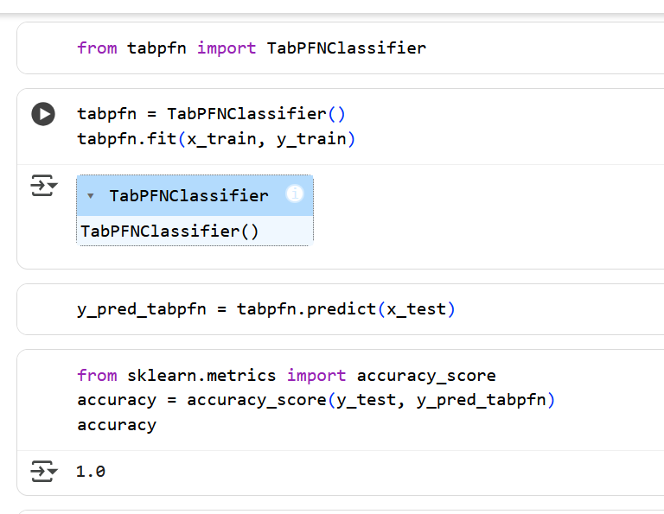

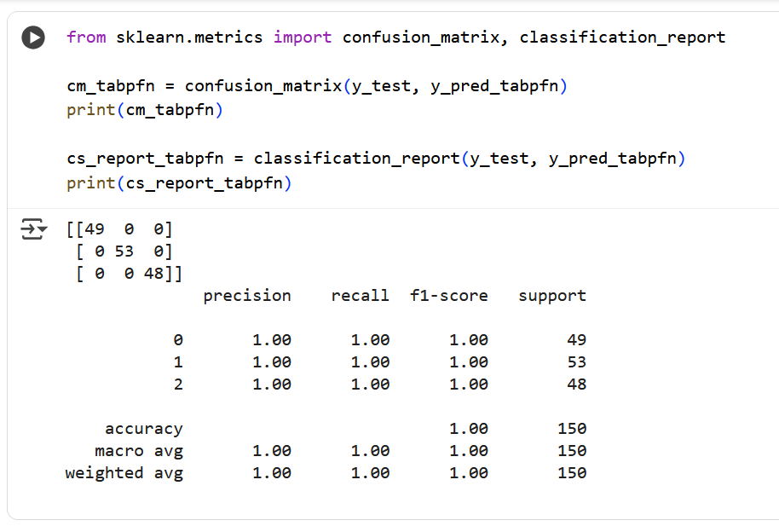

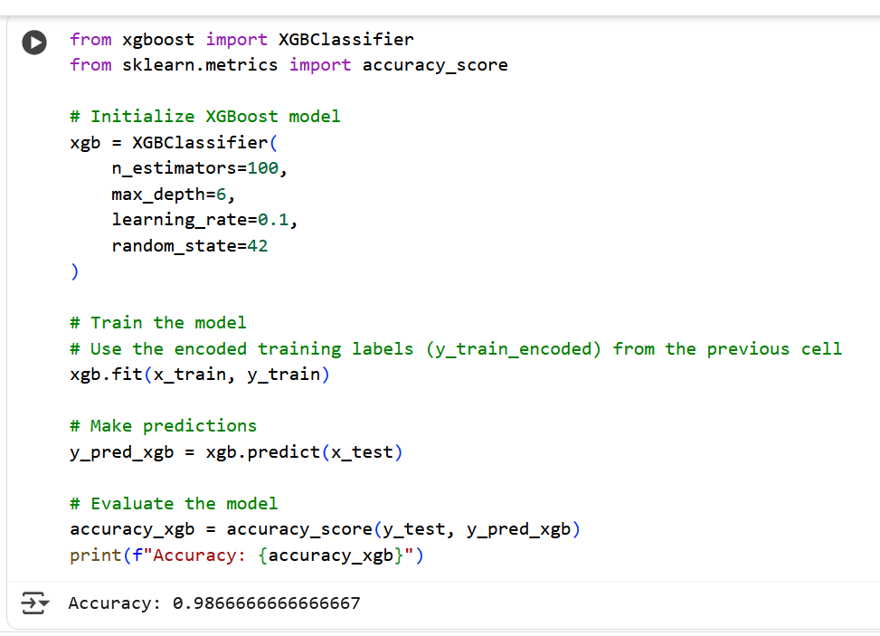

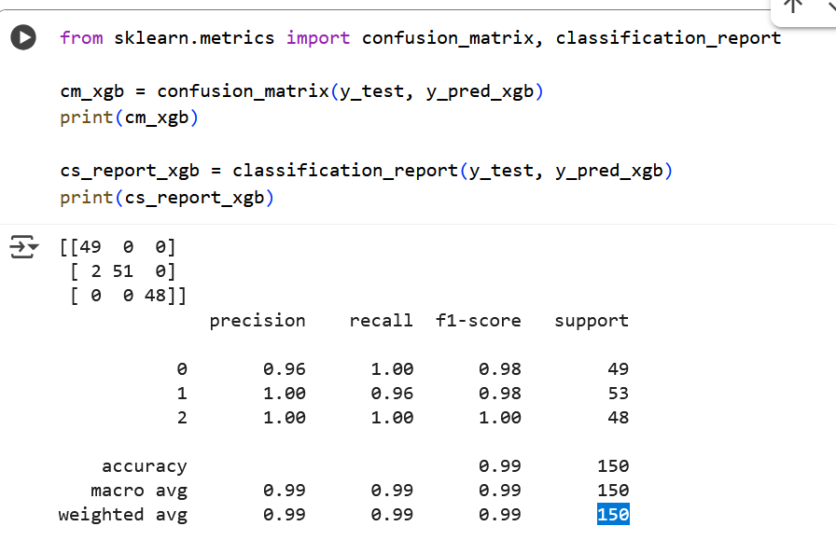

**Model Validation and Evaluation Report :**

| Model | Summary | Training and validation performance metrics |
| --- | --- | --- |
| Model - 1 : TabPFNClassifier |  |  |
| Model - 2 : XGBClassifier |  |  |